Sky Gazing Document

## C:\Users\adminn\AppData\Local\Microsoft\Windows\INetCache\Content.Word\Sky Gazing - Google Chrome 12_28_2023 9_26_35 AM.PNG

**BATCH CODE: PR-202307D**

**Submitted To:**

[eprojects@aptech.ac.in](mailto:eprojects@aptech.ac.in)

**Project Instructor:**

**Sir Muhammad Hashir Siddiqui**

Our Group Members:

## Muhammad Abdullah Siddiqui:

## (Student1489050)

## Muhammad Hussain Khan:

## (Student1488941)

## Syed Muhammad Taha:

## (Student1486391)

## Curriculum Code:

## Muhammad Abdullah Siddiqui :

## (OV-7062-ADSE)

## Syed Muhammad Taha:

## (OV-7066-HDSE)

## Muhammad Hussain Khan:

## (OV-7062-HDSE)

## TABLE OF CONTENT

**[Project certification……………………………………………………….……….4](#_PROJECT_CERTIFICATION)**

[**Introduction of Sky Gazing…………….……………………………………5**](#_INTRODUCTION_OF_SKY)

**[Page Duration………………………………………..………...6](#_PROJECT_DURATION_1)**

[**Home Section……………………………………………………………….………………....10**](#_HOME_PAGE)

[**About us…………………………………………………………………………………………10**](#_ABOUT_US_PAGE)

[**Gallery………………………………………………….……………………….….11**](#_GALLERY_SECTION)

[**Contact us……………………….……………………………………..….………………...12**](#_CONTACT_US_PAGE)

**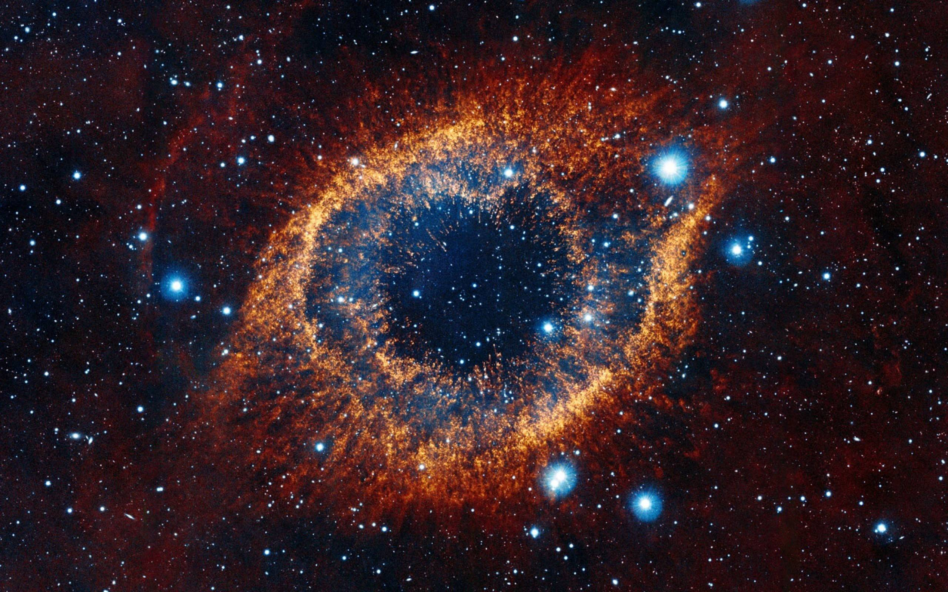**

**We are thankful to Almighty, ALLAH that by His grace we have been successful. We also thanks to “Sir Muhammad Hashir Siddiqui”**

**we presenting on Visual Studio Code in your hands.**

**This is our First Year Semester E-project. We have tried our best & struggled for a better outlook to come. This project has been developed in Visual Studio Code. We choose to make Webpage for Sky Gazing as a project. We find easy to do coding in Visual Studio Code.**

**We earnestly hope that this project will provide all the necessarily information required for the user to fulfill their inspiration. However, suggestions for improvement of the project will be thankful received & acknowledge**

**ACKNOWLEDGEMENT**

# **PROJECT CERTIFICATION**

***This is to certify that,***

***Muhammad Abdullah Siddiqui (Enrolment #Student1489050), Syed Muhammad Taha (Enrolment #1486391), Muhammad Hussain Khan(Enrolment #1488941), has successfully designed and developed:***

**Sky Gazing**

***Submitted by***

***Aptech computer Education***

***Date of issue:***

**15 Dec, 2023**

***Date of submission:***

**5 Jan, 2024**

# **INTRODUCTION OF SKY GAZING**

**"At Sky Gazing, we stand as pioneers in our field, tirelessly exploring the uncharted territories of technology, astronomy, sustainable travel, and multimedia with curiosity as vast as the cosmos. Our commitment to pushing boundaries, unveiling hidden wonders, and illuminating the extraordinary remains unparalleled."**

**1) The Home Page should be created making use of Frames.**

**2) A Menu should be created which would categorize all the information about the features provided in the Site For e.g. a Menu for Various thing in Space, a Menu for Moons, Nebula etc something like that.**

**3) The Webpage display should be categorized according to the things in our galaxy like if a User wants to see only Moons Section then click on view all explore button and select the section that redirect to your selected section .**

**4) A Products of features of Individual things in galaxy should be displayed on the Web Page along with the astronomical Observatories but detailed Features should be stored in Individual Word documents which can be downloaded or viewed by the User who wishes to see the same.**

**5) There Should be a “About Us” page which will give you the information of sky gazing company and also give information of Team members.**

**6) There Should be a “Gallery” page which will contain pictures that applied on a webpage.**

**7) There should be a “Contact Us” page which will have the Address of the Company which is as follows and the mail address which when clicked will invoke the local ail client from where they can send an email**.

**HARDWARE & SOFTWARE/REQUIRMENT**

**Hardware:**

* Intel Core i3/i5 Processor or higher
* 8 GB RAM or above
* Color SVGA
* 500 GB Hard Disk space
* Mouse
* Keyboard

**Software:**

Technologies to be used:

* Frontend: HTML5, CSS, Bootstrap, JavaScript, jQuery, AngularJS, XML
* Data Store: JSON files or TXT files

Other Requirements:

* Operating Portal: Windows
* Browsers: Edge, Chrome, Mozilla Firefox, Safari

# **PROJECT DURATION**

1. Analysis-18 Hrs.
2. Design – 22 Hrs.
3. Development –20Hrs
4. Testing – 12 Hrs
5. Documentation -11 hrs

TASK SHEET

|  |  |  |  |  |
| --- | --- | --- | --- | --- |
| NO. | Task | Start | Finish | Resource Names |
| 1. | **Analysis** | **15-Dec-23** | **17-Dec-23** | **Muhammad Abdullah Siddiqui, Syed Muhammad Taha, Muhammad Hussain Khan** |
| 2. | **Solution Design** | **18-Dec-23** | **20-Dec-23** | **Muhammad Abdullah Siddiqui, Syed Muhammad Taha, Muhammad Hussain Khan** |
| 3. | **Development** | **21-Dec-23** | **24-Dec-23** | **Muhammad Abdullah Siddiqui, Syed Muhammad Taha, Muhammad Hussain Khan** |
| 4. | **Documentation** | **26-Dec-23** | **28-Dec-23** | **Muhammad Abdullah Siddiqui, Syed Muhammad Taha, Muhammad Hussain Khan** |

**LIST OF VALIDATION**

|  |  |
| --- | --- |
| Option | Validation |
| Fields in Form should not be Null | **Yes** |
| Hyperlinks Have Alternating Text | **No** |
| Search Pages | **Yes** |
| Homepage Has Forward Only Link | **Yes** |
| All Web pages have link back to Homepage | **Yes** |
| Request Quote Form Included | **No** |
| All Functions Are Compatible with Firefox | **Yes** |
| All Functions Are Compatible with IE | **Yes** |

**SUBMISSION CHECK LIST**

|  |  |  |  |
| --- | --- | --- | --- |
| No. | List of Items | Remarks | Comments |
| 1) | **Do All Pages Linked together** | **Yes** |  |
| 2) | **Are structure (HTML), presentation (CSS), and behavior (JavaScript) separated** | **Yes** |  |
| 3) | **Are the links visible** | **Yes** |  |
| 4) | **Site Browser Compatible** | **Yes** | **Tested in Chrome, Microsoft Edge,Mozila Firefox,Opera .** |
| 5) | **Feedback Form Included** | **No** |  |
| 6) | **Project Zip File** | **Yes** | **Created using WinRAR** |

# **HOME SECTION**

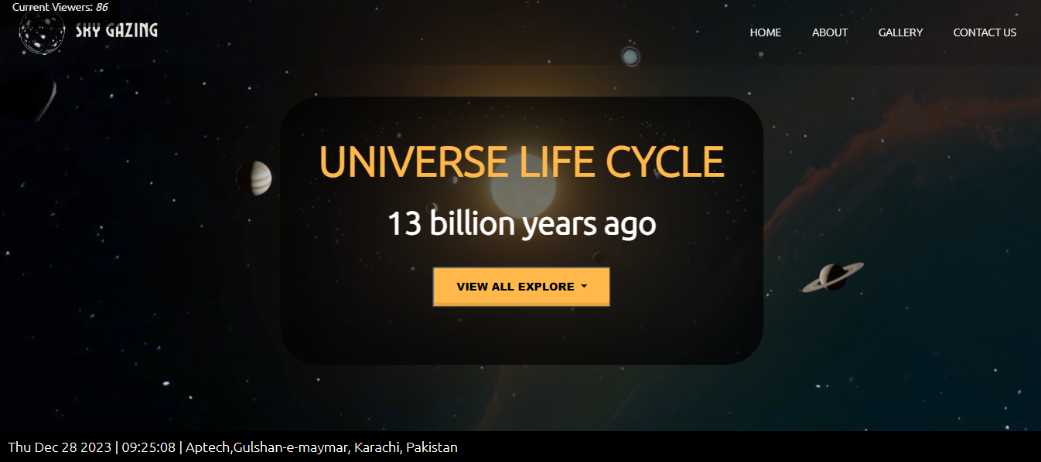

# **ABOUT US SECTION**

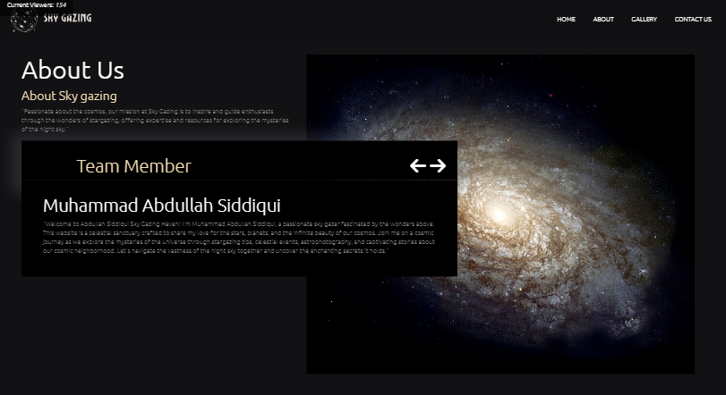

# **GALLERY SECTION**

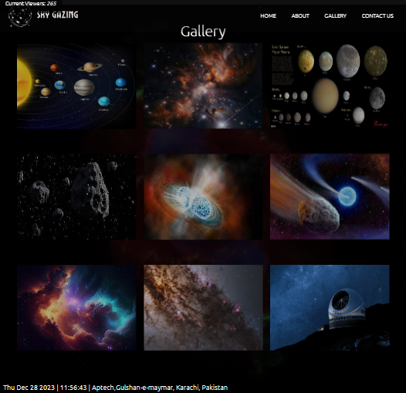

# **CONTACT US SECTION**

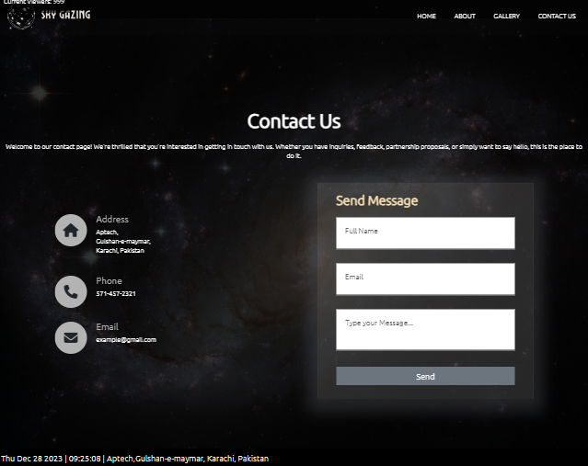

**THANK YOU**

**……….YOUR REGARDS……….**

**“IF YOU ANY QUERIES PLEASE CHECK OUR WEBSITES”**